Hyrja për 20 pc: 06.04.2018
20 (k-1-20) Kompjutera HP-Compaq,të përdorur, pa sistem (bosh) nga ProCredit Bank (2008?!)
Përdorues të konfiguruar:
- test|pass:dbi|pass hint: fti (administratori)
- student (perdoruesi)

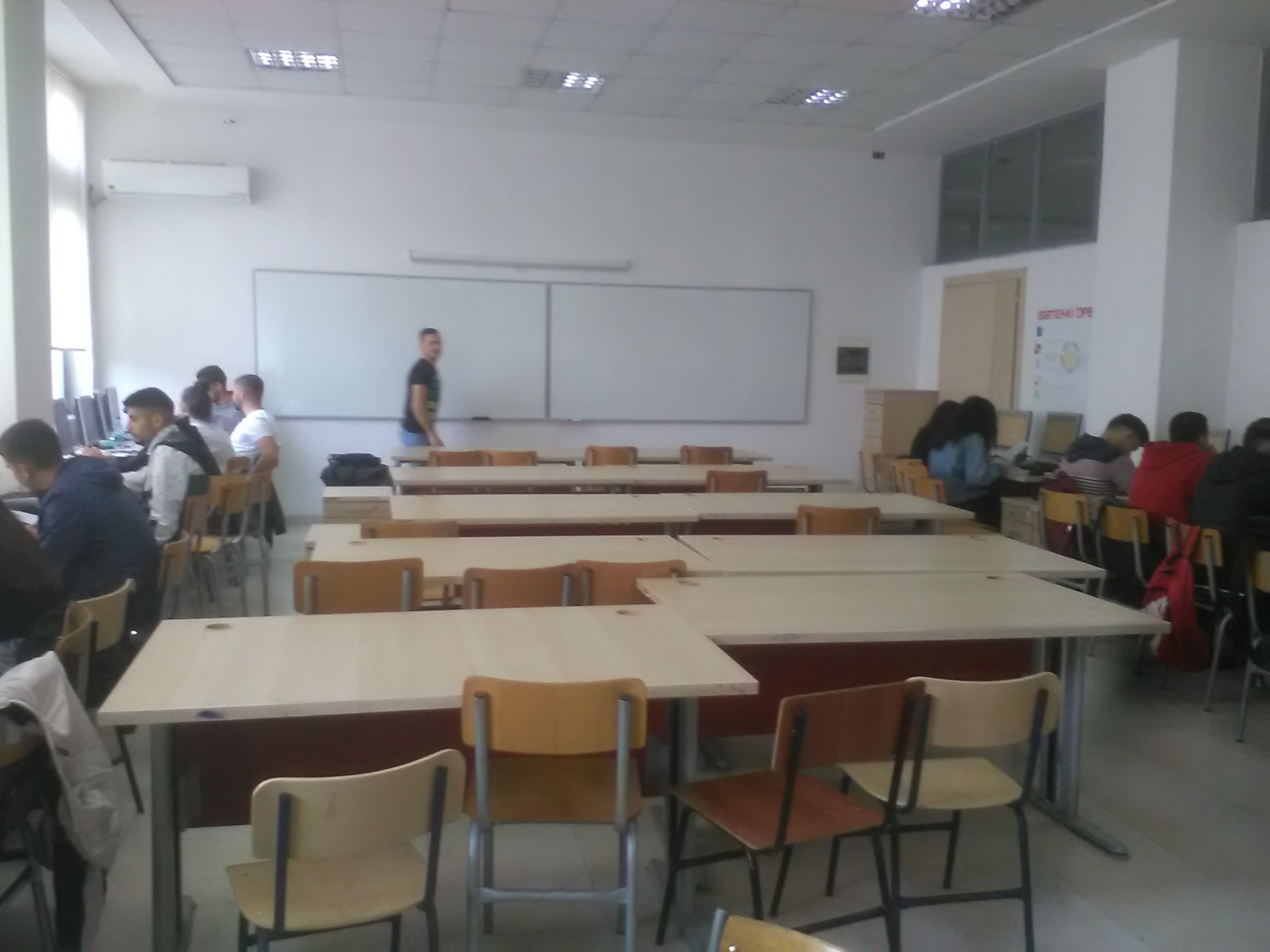

1. Kondicioneri | Ngrohja qendrore
2. Tavolinat nga ProCredit: 20
3. Komodina nga ProCredit:19+1(fotokopja)
4. Kompjutera nga ProCredit:20 (Duhen RAM !!)
5. 2 Tabela të bardha (lapustil)
6. 45 karrige
7 6 shirita perde
9. 3 njësi kompjuteri jo funksionale

Emri i kompjuterit | CPU (GHz) | DDR2-SDRAM  (GB) | HDD (GB) | Soft | KOMENTE
k-1 | Intel ® Celeron ® CPU 440 @ 2 GHz | 1 | 150=130+20 | Win 10 64-bit,cpu-z, speccy, Raptor,  c-free5, devcpp, office 2007, Matlab2015-64bit-version portabël
k-2 | Intel ® Celeron ® CPU 440 @ 2 GHz | 1 | 150=100+50 | Win 10 64-bit,cpu-z, speccy, Raptor,  c-free5, devcpp, office 2007, Matlab2015-64bit-version portabël
k-3 | Pentium® Dual-Core E5300 CPU 2.6 GHz, | 2 | 300=150+100+50 | Win 10 64-bit,cpu-z, speccy, Raptor,  c-free5, devcpp, office 2007, Matlab2015-64bit-version portabël
k-4 | Pentium® Dual-Core E5300 CPU 2.6 GHz, | 2 | 300=150+100+50 | Win 10 64-bit,cpu-z, speccy, Raptor,  c-free5, devcpp, office 2007, Matlab2015-64bit-version portabël
k-5 | Intel ® Celeron ® CPU 440 @ 2 GHz | 1 | 150=100+50 | Win 10 64-bit,cpu-z, speccy, Raptor,  c-free5, devcpp, office 2007, Matlab2015-64bit-version portabël | Me CD/DVD te jashtem instalimi win 10, s hap suportin!!
k-6 | Intel ® Core (TM) 2 Duo CPU E15002.2GHz, | 1 | 150=100+50 | Win 10 64-bit,cpu-z, speccy, Raptor,  c-free5, devcpp, office 2007, Matlab2015-64bit-version portabël
k-7 | Intel ® Celeron ® CPU 440 @ 2 GHz | 1 | 150=100+50 | Win 10 64-bit,cpu-z, speccy, Raptor,  c-free5, devcpp, office 2007, Matlab2015-64bit-version portabël | Probleme startimi, butoni startimit s’ kontakton korrekt!!! CD/DVD s del në explorel (ne dollap u zevendësua)
k-8 | Intel ® Celeron ® CPU 440 @ 2 GHz | 1 | 150=100+50 | Win 10 64-bit,cpu-z, speccy, Raptor,  c-free5, devcpp, office 2007, Matlab2015-64bit-version portabël
k-9 | Intel ® Celeron ® CPU 440 @ 2 GHz | 1 | 150=100+50 | Win 10 64-bit,cpu-z, speccy, Raptor,  c-free5, devcpp, office 2007, Matlab2015-64bit-version portabël | Pulsonekroani
k-10 | Intel ® Celeron ® CPU 440 @ 2 GHz | 1 | 150=100+50 | Win 10 64-bit,cpu-z, speccy, Raptor,  c-free5, devcpp, office 2007, Matlab2015-64bit-version portabël
k-11 | Intel ® Core (TM) 2 Duo CPU E1500 2.2GHz | 1 | 150=100+50 | Win 10 64-bit,cpu-z, speccy, Raptor,  c-free5, devcpp, office 2007, Matlab2015-64bit-version portabël
k-12 | Intel ® Celeron ® CPU 440 @ 2 GHz | 1 | 150=100+50 | Win 10 64-bit,cpu-z, speccy, Raptor,  c-free5, devcpp, office 2007, Matlab2015-64bit-version portabël | Verifiko
k-13 | Intel ® Celeron ® CPU 440 @ 2 GHz | 4 | 150=100+50 | Win 10 64-bit,cpu-z, speccy, Raptor,  c-free5, devcpp, office 2007, Matlab2015-64bit-version portabël
k-14 | Intel ® Celeron ® CPU 440 @ 2 GHz | 1 | 150=100+50 | Win 10 64-bit,cpu-z, speccy, Raptor,  c-free5, devcpp, office 2007, Matlab2015-64bit-version portabël
k-15 | Intel ® Celeron ® CPU 440 @ 2 GHz | 2 | 150 | Win 10 64-bit,cpu-z, speccy, Raptor,  c-free5, devcpp, office 2007, Matlab2015-64bit-version portabël | NTLDR is missing. Me CD/DVD te jashtem instalimi win 10
k-16 | Intel ® Celeron ® CPU 440 @ 2 GHz | 1 | 150=100+50 | Win 10 64-bit,cpu-z, speccy, Raptor,  c-free5, devcpp, office 2007, Matlab2015-64bit-version portabël | Verifiko..!!!!
k-17 | Intel ® Celeron ® CPU 440 @ 2 GHz | 1 | 150=100+50 | Win 10 64-bit,cpu-z, speccy, Raptor,  c-free5, devcpp, office 2007, Matlab2015-64bit-version portabël
k-18 | Intel ® Core (TM) 2 Duo CPU E1500 2.2GHz, | 1 | 150=100+50 | Win 10 64-bit,cpu-z, speccy, Raptor,  c-free5, devcpp, office 2007, Matlab2015-64bit-version portabël | CD/DVD=ERROR 0x 0…ndaj u krye me pajisjetëjashtmeinstalimi win 10,
k-19 | Intel ® Core (TM) 2 Duo CPU E1500 2.2GHz, | 1 | 150=100+50 | Win 10 64-bit,cpu-z, speccy, Raptor,  c-free5, devcpp, office 2007, Matlab2015-64bit-version portabël
k-20 | Intel ® Celeron ® CPU 440 @ 2 GHz | 1 | 80=41.5+32.54 HDD u ndërrua controller i diskut jep gabim | Win 10 64-bit,cpu-z, speccy, Raptor,  c-free5, devcpp, office 2007, Matlab2015-64bit-version portabël | CD/DVD=ERROR 0x 0…ndaj u krye me pajisjetëjashtmeinstalimi win 10,
Brunela  ACER | AMD Athlon(TM)II X3 455 procesor | 4 | 300=150+100+50 | Win 10 64-bit,cpu-z, speccy, Raptor,  c-free5, devcpp, office 2007, Matlab2015-64bit-version portabël

Softe të tjera instaluar: Advanced-systemcare, Malware fighter, Driver-Bootster, CPU-Z, Speccy, ccleaner, , google chrome, flash player, winzip, Raptor.

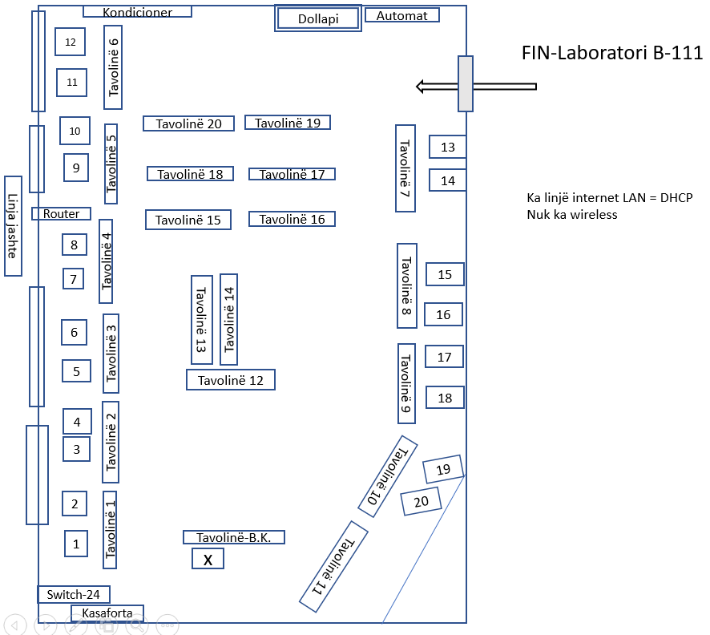

Ndarja e burimeve në rrjet: në 21 kompjutera është 1 direktori k-x(x=1deri 20)e ndarë në rrjet.
Nga kompjuteri Brunela mund të kopjohen skedarët e nevojshëm për laboratorët e studentëve në 20 kompjuterat e tjerë.
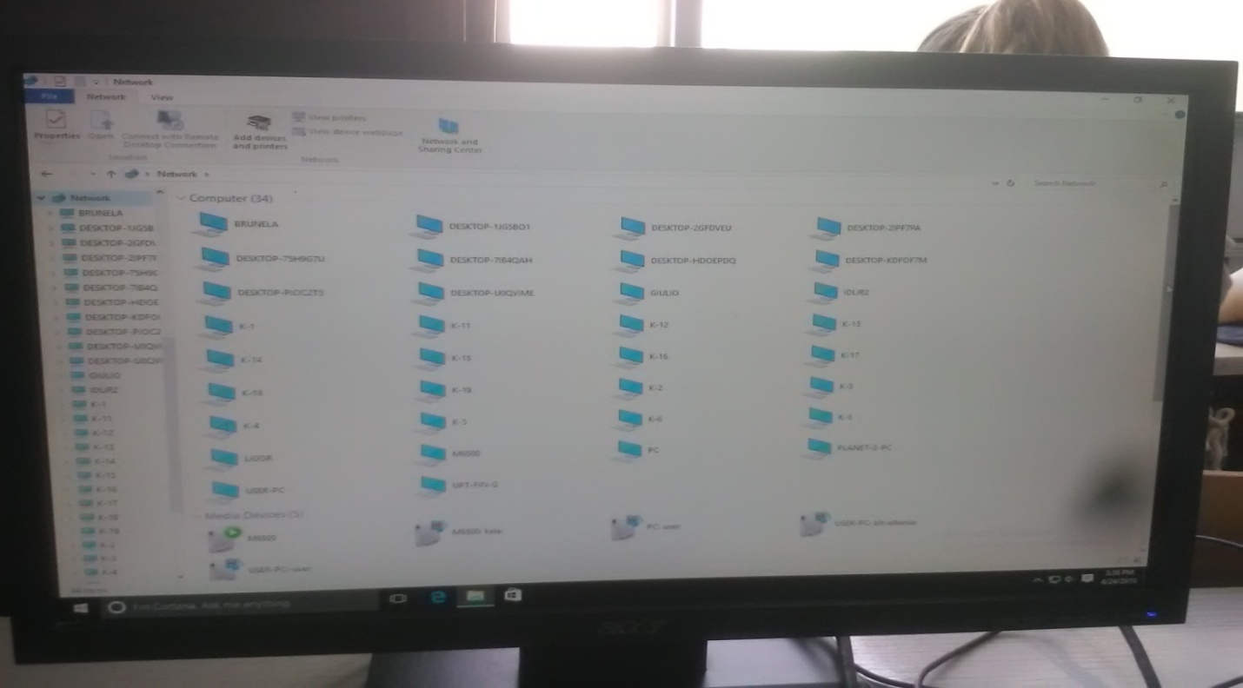
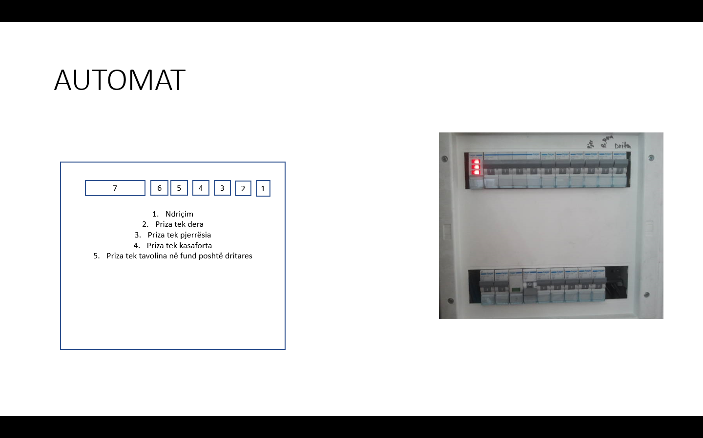

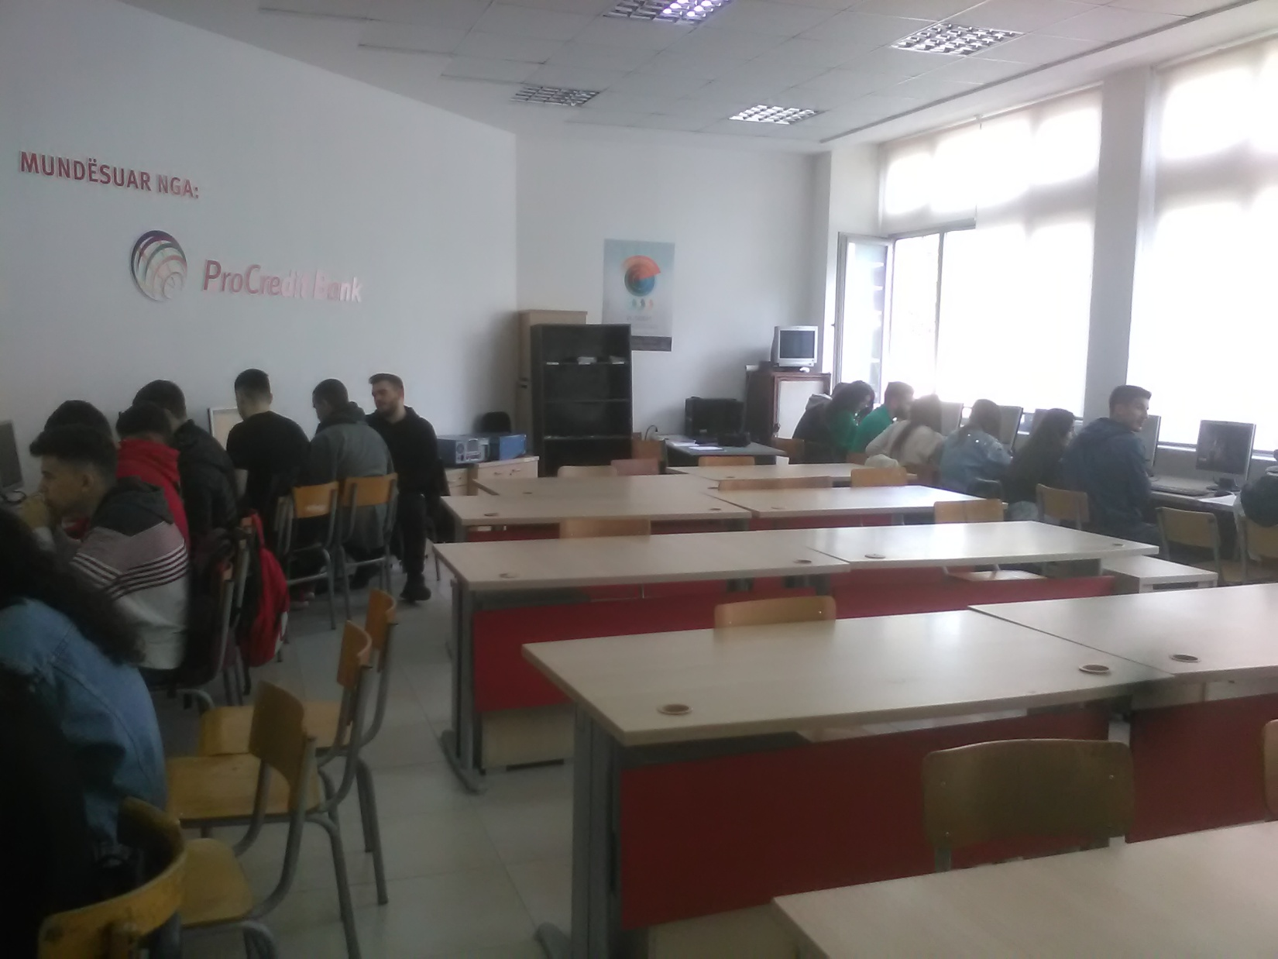
- Kompjuteri k-20 iu hoq hdd dhe u vendos një sata 80 GB, sepse ekzistuesi nuk mundësonte boot. (Aktivizimi në BIOS i kontrollerit përsëri nuk lejonte boot!!)
Shënim: Inventari i pajisjeve tavolina s’ mund të mbahet sipas barkodit sepse letra mbi tavolinë mund të griset lehtësisht, por sipas përmasave, të cilat në dokumentacion duhet të përputhen me barkodin përkatës.

